QUESTION NO -1:
Aim
To develop a Python program to represent the distribution of grades obtained by 40 students using a pie chart and a bar chart, identify the maximum and minimum grades by student count, and calculate the combined percentage of students who secured grades A and S.

Algorithm
- Start the program.
- Store the grades F, E, D, C, B, A and S in a list.
- Store the corresponding number of students as 3, 4, 5, 8, 9, 7 and 4.
- Calculate the total number of students and the percentage for each grade.
- Draw a pie chart showing the percentage distribution of grades.
- Display grade labels and percentage values on the pie chart.
- Draw a bar chart comparing the number of students in each grade.
- Label the X-axis as Grades and the Y-axis as Number of Students.
- Display the exact number of students above each bar.
- Identify the grades with the maximum and minimum number of students.
- Calculate the combined percentage of students who secured grades A and S.
- Display the results.
- Stop the program.

CODE:

import matplotlib.pyplot as plt

# Store grades and number of students
grades = ['F', 'E', 'D', 'C', 'B', 'A', 'S'] students = [3, 4, 5, 8, 9, 7, 4]

# Calculate total students total = sum(students)

print("Total number of students:", total) print("\nGrade-wise student details:")

# Calculate and display percentages for i in range(len(grades)):
percentage = (students[i] / total) * 100 print(grades[i], ":", students[i],
"students -", round(percentage, 2), "%")

# Pie chart plt.figure(figsize=(7, 6)) plt.pie( students, labels=grades, autopct='%1.1f%%', startangle=90
)
plt.title("Percentage Distribution of Student Grades") plt.legend(grades, title="Grades") plt.show()

# Bar chart plt.figure(figsize=(8, 5)) bars = plt.bar(grades, students) plt.xlabel("Grades") plt.ylabel("Number of Students") plt.title("Number of Students in Each Grade")

# Display values above bars plt.bar_label(bars)

plt.show()

# Find maximum and minimum max_count = max(students) min_count = min(students)

max_grades = [ grades[i] for i in range(len(grades)) if students[i] == max_count
]

min_grades = [ grades[i] for i in range(len(grades)) if students[i] == min_count
]

print("\nMaximum students:", max_grades, "-", max_count) print("Minimum students:", min_grades, "-", min_count)

# Combined percentage of A and S
combined = students[5] + students[6] percentage = (combined / total) * 100

print("Students with grades A and S:", combined) print("Combined percentage of A and S:", round(percentage, 2), "%")

Expected output :
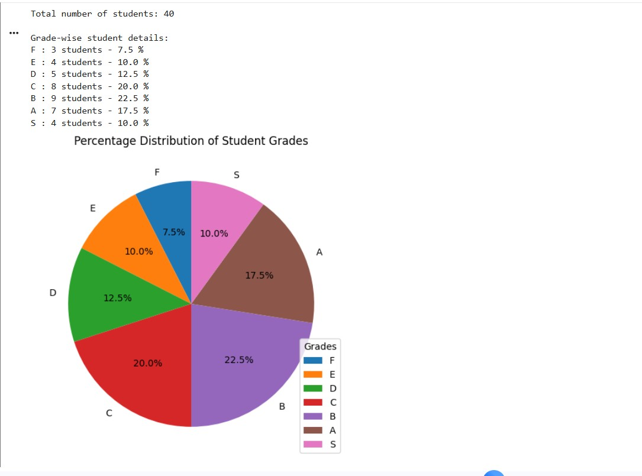

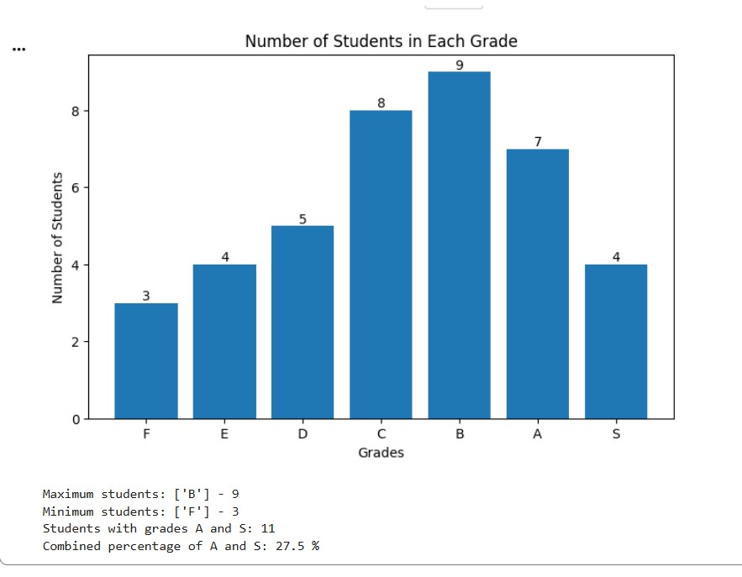
Question No:2
2) Semantic Network Using NetworkX Aim: To represent concepts and labeled relationships as a directed semantic network. Software Required: Python 3.x and NetworkX (install with: pip install networkx)

Algorithm: Semantic Network Using NetworkX
- Start.
- Import the networkx library.
- Create a directed graph.
- Add concepts as nodes through edges.
- Add relationships between concepts, such as is-a and has-instance.
- Display each relationship between the concepts.
- Draw the semantic network graph.
- Display the graph with labeled nodes and edges.
- Stop.

Program:

!pip install networkx matplotlib

import networkx as nx
import matplotlib.pyplot as plt

# Create a directed graph
G = nx.DiGraph()

# Add concepts and relationships
G.add_edge("Dog", "Mammal", relation="is-a")
G.add_edge("Mammal", "Animal", relation="is-a")
G.add_edge("Dog", "Tommy", relation="has-instance")

# Display relationships
print("Semantic Network Relationships:")
for source, target, data in G.edges(data=True):
print(source, "--", data["relation"], "-->", target)

# Draw the semantic network
pos = nx.spring_layout(G, seed=42)
nx.draw(G, pos, with_labels=True, node_color="lightblue",
node_size=2500, font_size=10, arrows=True)

edge_labels = nx.get_edge_attributes(G, "relation")
nx.draw_networkx_edge_labels(G, pos, edge_labels=edge_labels)

plt.title("Semantic Network")
plt.show()

OUTPUT:
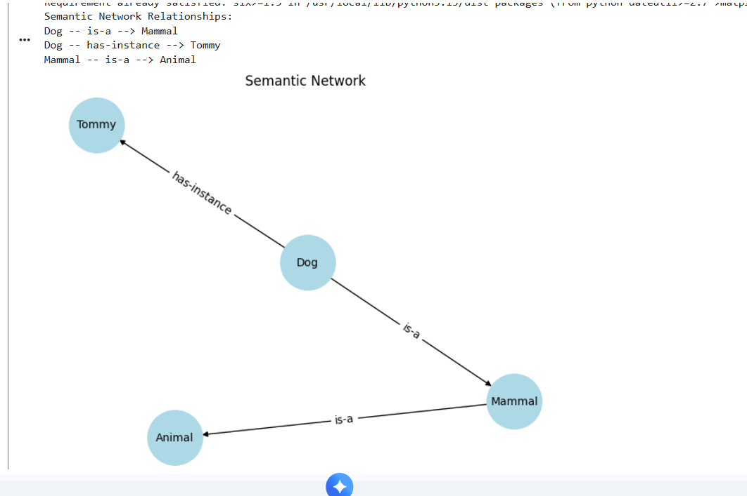

QUESTION NO-3:
3) Frame-Based Knowledge Representation
Aim: To represent an object as a frame containing slots and values.
Software Required: Python 3.x
Algorithm: Frame-Based Knowledge Representation
- Start.
- Create a dictionary to represent a vehicle frame.
- Store the vehicle details as slots and values.
- Include slots such as class, brand, fuel type, wheels, and color.
- Display the title "Vehicle Frame".
- Use a loop to access each slot and its corresponding value.
- Print all the slots and values.
- Stop.

CODE:

# Create a vehicle frame using a dictionary
vehicle = {
"class": "Vehicle",
"brand": "Toyota",
"fuel_type": "Petrol",
"wheels": 4,
"color": "White"
}
# Display the frame
print("Vehicle Frame")
for slot, value in vehicle.items():
print(slot, ":", value)
OUTPUT:
